TC-REF-009
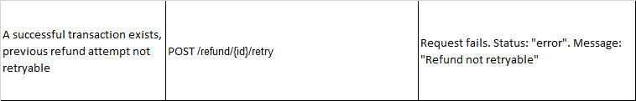
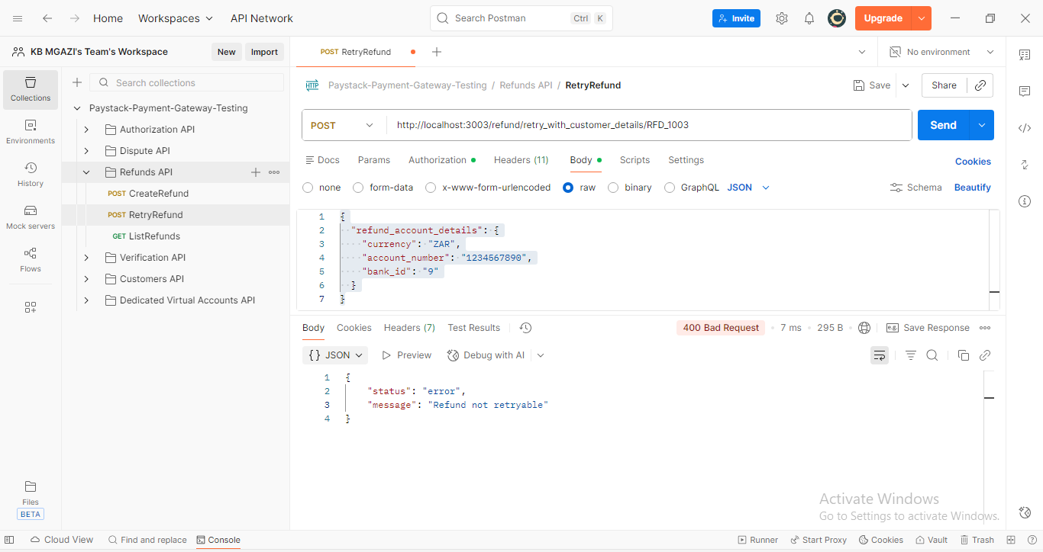
Request:
{
"refund_account_details": {
"currency": "ZAR",
"account_number": "1234567890",
"bank_id": "9"
}
}

Response:
{
"status": "error",
"message": "Refund not retryable"
}

